Scott Chamberlain
CSD325 – Module 10.2 Assignment
5/17/2026

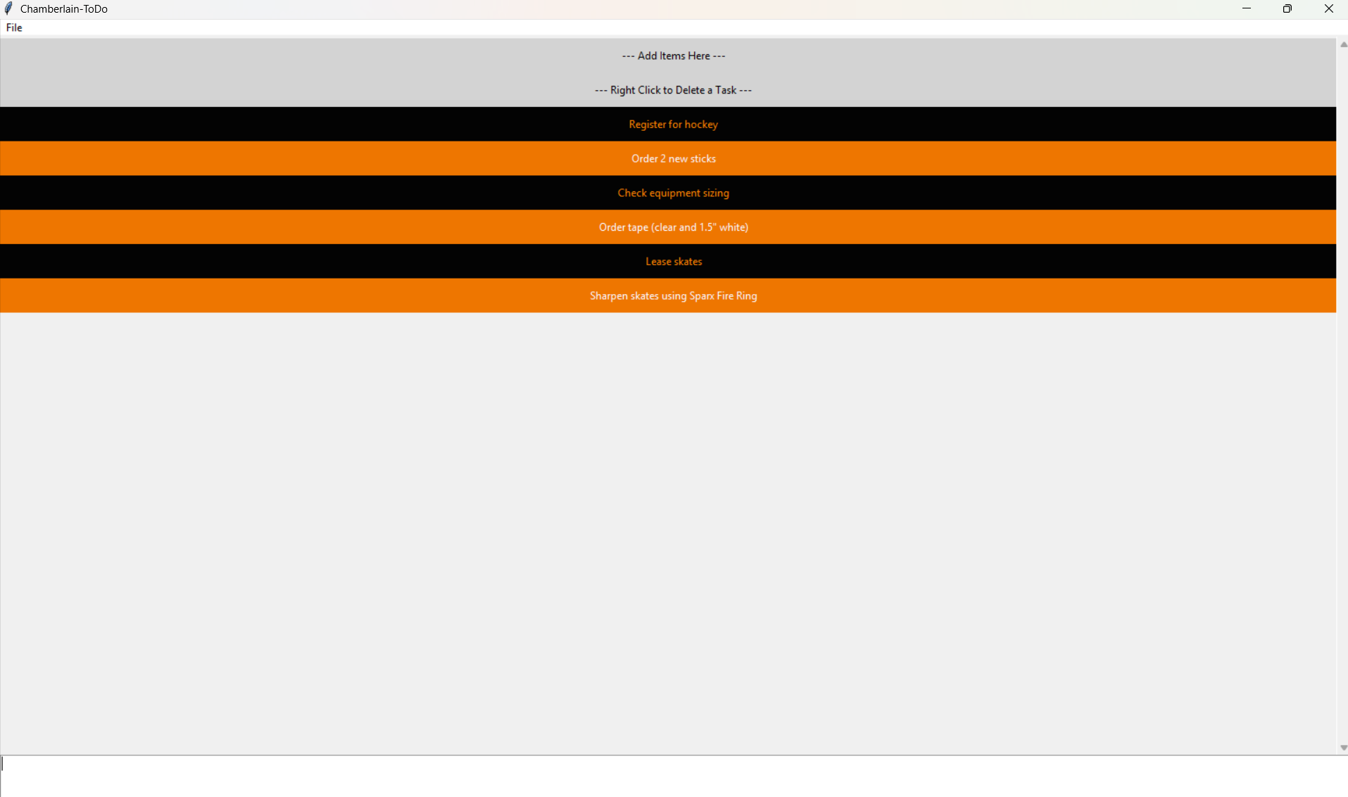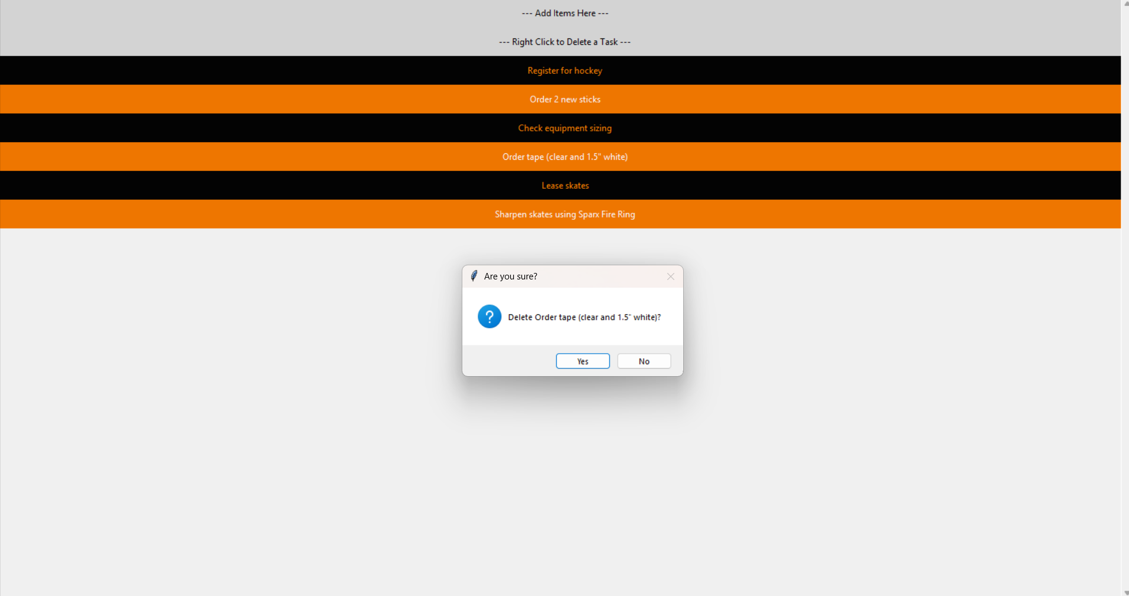
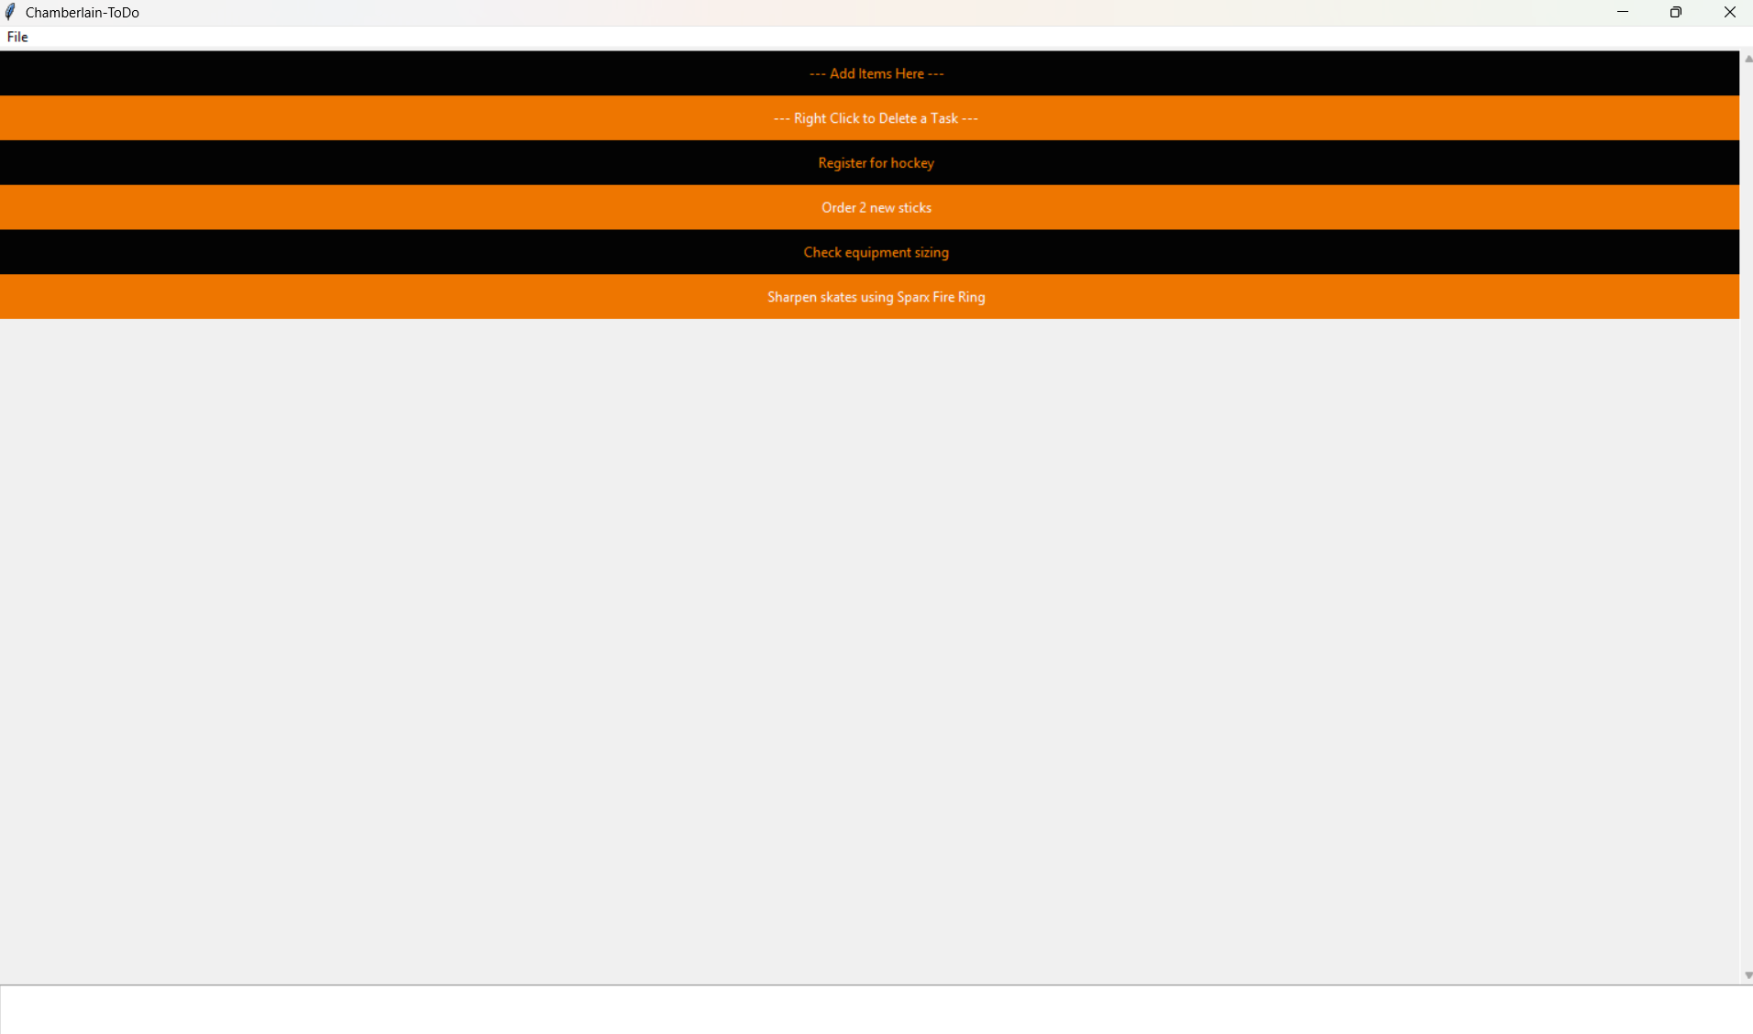
I couldn’t figure out how to prevent the ---Add items--- and ---Right Click to Delete--- from changing colors!

